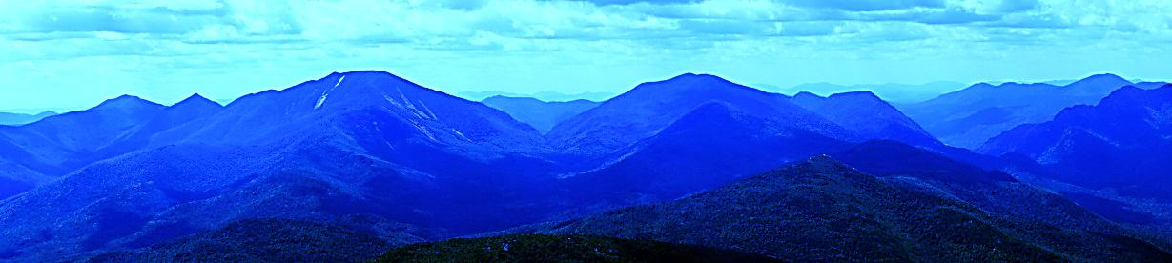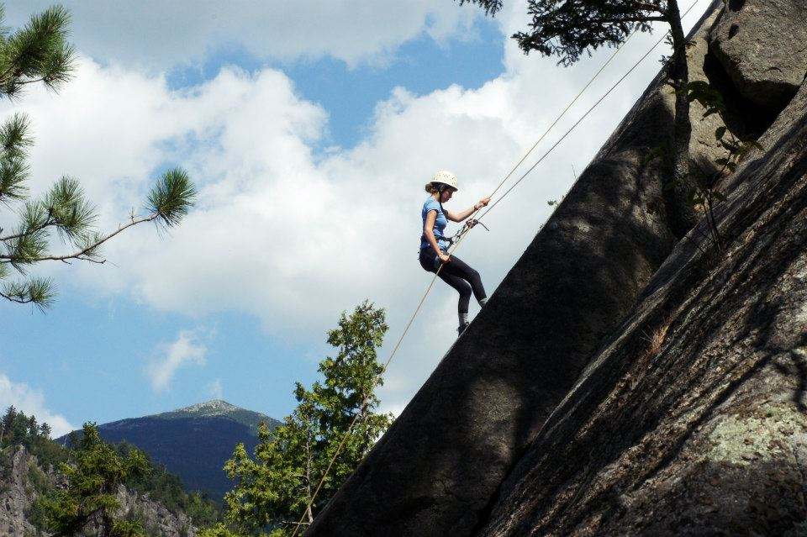

*“...Modern education, while catering admirably for individual mental and physical skills, has not yet succeeded in teaching people how to live and work together, and to accept rational discipline for the common good. (Many)…have come to the conclusion that to achieve this vital object it is essential to work in an environment which of its very nature must be taken seriously — and this had led them inevitably either to the mountains or to the sea.”*

-Lord Burnham

LandSea Participant’s Handbook

6th Edition

Chapter 1: Overview of LandSea 2

1.1: Overview of LandSea 2

Chapter 2: Wilderness Environment 4

2.1: Leave No Trace 4

2.2: Adirondacks 5

Chapter 3: Backcountry Living 10

3.1: Setting Up Camp 10

3.2: Cooking 14

3.3: Water Treatment 16

3.4: Nutrition 16

3.5: Hygiene 18

3.6: Preventative First Aid 20

Chapter 4: Navigation 22

4.1: Navigation 22

Chapter 5: Hiking 29

5.1: Hiking Locations 29

5.2: Backpacking Equipment 30

5.3: Hiking Technical Skills 31

Chapter 6: Canoeing 34

6.1: Canoeing Locations 34

6.2: Canoeing Equipment 34

6.3: Paddle Strokes 36

6.4: Portaging 41

6.5: River Features 42

Chapter 7: Climb & Rappel 45

7.1: Purpose of Climb & Rappel 45

7.2: Equipment 45

7.3: Climbing & Belaying 50

Chapter 8: Service & Reflection 51

8.1: Components of Service & Reflection 51

8.2: Service 51

8.3: Reflection 52

8.4: Solo 53

Chapter Expedition Behavior 54

10.1: Expedition Behavior 54

**Chapter 1: Overview of LandSea**

1.1: Overview of LandSea

*1.1.1:**Mission Statement*

To provide opportunity for personal development through living simply and ethically, shared experience in the outdoors and working respectfully with others. LandSea fosters the transference of skills and experience back to campus and life beyond “K.”

*1.1.2: Philosophy*

LandSea follows a philosophy of experiential education. LandSea participants spend minimal time in formal instruction. Instead, the peaks, valleys, rivers, lakes and crags of the Adirondacks offer ample opportunity for students to learn and grow in a supportive, intentional community.

Backcountry living and travel provide daily challenges that require maturity, creative thinking and, most importantly, cooperation and communication among a group of peers. We believe that facing these challenges over an extended period of time, with guidance from student trip leaders and in a group of peers, provide a unique and authentic experience for LandSea participants to grow as individuals and as a group. Structured reflection, facilitated by trip leaders and staff, coupled with the circumstances of the expedition offer excellent opportunities for individuals to instruct and to learn from one another. This wilderness environment allows the participants to reflect on their own identities as individuals and as members of a group. Through open and free interactions with others in a challenging environment, a better understanding of one's self is achieved.

*1.1.3: Details*

Two of the major components of LandSea consist of backpacking and canoeing. Participants have a choice to extend (in distance traveled) either the backpacking or canoeing portion of the trip. In addition, each group will have the opportunity to participate in a 48-hour Service & Reflection experience and a day of Climb & Rappel.

The program, on average, receives twenty-percent of the incoming students to the College each year. For trail, those students are divided into smaller “patrols” of 7-9 participants, each led by 2 trained student leaders. Two patrols, referred to as sister patrols and given a letter designation [A1, A2, B1, B2, etc.], shadow each other through the park on a similar route/itinerary and collectively make up a Group [A Group, B Group, etc.]. The LandSea staff is responsible for permanently staffing the program, training student leaders, and all other logistical and administrative matters. Logistics Leaders work closely with staff to manage the day-to-day operations of the program and of Trip Leader Training—offering support to Trip Leaders and generally helping everything run smoothly. Throughout the program, interactions with the leaders, staff, and other participants will provide incoming students with a substantial opportunity to become acquainted with other members of the "K" College community.

*1.1.4: Aims*

*"The aim of education is to impel people into value forming experiences to ensure the survival of these qualities: an enterprising quality, an undefeatable spirit, tenacity and pursuit, readiness for sensible self- denial and above all compassion."*

-Kurt Hahn, Founder of Outward Bound

* To provide a bridge from high school to “K” College and an opportunity to establish a strong support group among other students
* To leave much of our technologically advanced society behind us
* To learn to live simply in the woods and develop wilderness skills, ethics, awareness, and appreciation
* To build skills in teamwork, listening, conflict resolution, cooperation, followership, and leadership
* To develop our ability to choose how we behave and respond to situations
* To further develop as a person: building awareness, esteem, confidence, responsibility, and self-reliance
* To have fun!

**Chapter 2: Wilderness Environment**

2.1: Leave No Trace

On LandSea, we follow a Leave No Trace (LNT) philosophy that seeks to limit our impact upon our environment. The seven principles of LNT are:

*2.1.1: The Seven Principles*

1. ***Plan Ahead and Prepare*** 
   * Look up regulations and special concerns for the park before you leave.
   * Prepare for extreme weather, hazards, and emergencies.
   * Repackage food to minimize waste.
2. ***Travel and Camp on Durable Surfaces***

* Durable surfaces include established trails and campsites, rock, gravel, dry grasses or snow.
* Camp at least 200 feet from lakes and streams.
* Walk single file.
* When established trails or campsites are unavailable, disperse the group throughout the area and avoid places where impact is beginning to show.

1. ***Dispose of Waste Properly*** 
   * Pack it in, pack it out.
   * Dig cat holes 6-8 inches deep to deposit solid human waste or biodegradable soap. These should be at least 200 feet from water and should be covered up and disguised when finished.
2. ***Leave What You Find***
   * Historic structures should be observed but not touched.
   * Avoid introducing or transporting non-native species into the area.
   * Do not build structures.
3. 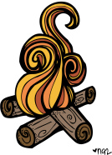***Minimize Campfire Impacts*** 
   * Use alternatives when possible for cooking, heat, and light.
   * Use established rings, fire pans, or fire mounds.
   * Use only small sticks on the ground that can be broken by hand. Keep fires small.
   * Burn the sticks and coals to ash, extinguish fire completely, and then scatter ashes.
4. ***Respect Wildlife***
   * Observe only from a distance.
   * Do not feed animals; store food securely where animals cannot access it.
5. ***Be Considerate of Other Visitors***
   * Be courteous; yield to others on trail.
   * Take breaks and camp away from trails and other visitors.
   * Avoid loud noises.

2.2: Adirondacks

*2.2.1: History of the Park*

The Adirondack Park was created in 1892 by the state of New York mainly out of growing concerns about water and timber resource conservation in the region. The park consists of 6 million impressive acres—it is the largest publicly protected area in the contiguous United States, and is larger than Yosemite, Yellowstone, Glacier, Grand Canyon, and the Great Smokies National Parks combined. Within this huge expanse of land is a diverse patchwork of different land functions and ownership. Approximately half is owned by the people of New York State and is constitutionally protected as “Forever Wild” forest reserve; the other half is private property: farms, homes, camps, and businesses. In fact, about 130,000 people (almost double the population of the city of Kalamazoo) live in the Adirondack State Park year-round! This unique blend of private and public land is an innovative strategy allowing conservation and civilization to co-exist and thrive.

The Adirondacks are a great destination for canoeing and kayaking with 30,000 miles of rivers and streams, as well as hiking with over 2,000 miles of hiking trails. The scenery you can encounter while exploring the Adirondacks varies from low-lying wetlands to mountain peaks. The 46 tallest mountains within the park are called the High Peaks with Mount Marcy being the tallest at 5,343 feet above sea level.

*2.2.2: Geology*

While the rocks that make up the Adirondacks are some of the oldest in the region, most major geographic features of the region did not appear until the last Ice Age which was about 10,000 years ago. Huge boulders called erratics exist in otherwise boulder-free areas of the park (such as the summit of Mt. Marcy) that were carried there by moving ice sheets and dropped when glaciers melted at the end of the Ice Age.

[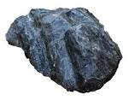](http://www.google.com/url?url=http://genkaku-again.blogspot.com/2014/02/like-rock.html&rct=j&frm=1&q=&esrc=s&sa=U&ei=TyslVdvpOsLGsAWMl4HQBA&ved=0CCAQ9QEwBQ&usg=AFQjCNHh_NTcRpfgNA7tjXiFW2MmfQUuag)The mountains are mostly made of Anorthosite, which usually exists well underground, and is common on the moon. Another distinctive geographic feature of the Adirondacks are the many fissures that punctuate the mountains in the form of valleys, lakes, and passes at a northeast-southwest orientation as a result of further glacial erosion.

*2.2.3: The High Peaks*

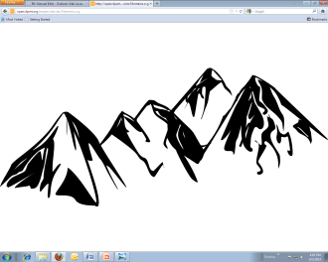The High Peaks region of the park consists of New York’s highest 46 Peaks (each above an elevation of 3800 ft). Above the tree line in this region is where the rare Arctic-Alpine elevation areas (85 acres in total) in the Adirondacks may be found. These areas are home to a wide variety of endangered and rare species of plants, moss, and lichens. Some of these species resemble more common ones, but are much more fragile and must be protected. For example, Deer’s Hair Sedge looks like a common grass, and is treated as such by many hikers, which impedes its conservation.

*2.2.4: Ecology*

The majority of the southern section of Adirondack State Park is comprised of one of the largest intact temperate forests in the world. This biome is known for year-round precipitation (between 30-60 inches), fertile soil, and distinct seasons of winter, spring, summer, and fall. Here, you will find deciduous plant life such as Maple, Walnut, and Birch trees as well as lichen, moss, ferns, and wildflowers. Wildlife species include insects, spiders, frogs, deer, raccoons, opossums, and red foxes. Many migratory bird species make their home here for a portion of the year, including the common loon.

The Boreal Forest Biome includes some low-lying areas in the northern region of the park and high elevation summits. These Boreal zones are unique, because they are typically found much farther north. This biome is also known as Taiga, and is characterized by low temperatures year-round and coniferous vegetation.

*2.2.5: Conservation and Preservation*

Ensuring the conservation and care of Adirondack State Park is important for the wildlife that lives there as well as for humans. The park includes the headwaters of 5 major watersheds, which are important targets for environmental protection. If these headwaters become polluted, there is a chance those pollutants could affect the rest of the watershed as well. Certain plant and animal species are used to gauge the health of the environment. For example, the health of the Common Loon population in the Adirondacks is used as an indicator to measure the presence of toxins (e.g. Mercury) in the park. The loon is a migratory bird near the top of the food chain. By virtue of being a top predator, the loon is susceptible to toxins such as mercury aggregating in its body via the food it consumes. A healthy loon population usually means low toxin concentrations in the park.

The Adirondack State Park includes some ecosystems that are especially sensitive to the threat of climate change, including open peat lands, open river corridors, conifer swamps, and alpine tundra. Wetlands are important sources of biodiversity and pollution buffers for the surrounding environment.

*2.2.6: Wildlife*

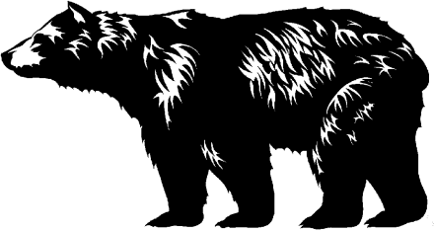 **Bears**

Black bears are omnivorous and feed on grasses, berries, fruits, nuts, seeds, insects, grubs, and carrion. The average black bear male weighs 300 pounds, as opposed to the female’s 170 pounds. Bears’ sense of smell is very sensitive—the smallest traces of human food can attract them and is the most common cause of bear-human encounters. Under no circumstance should anyone feed a wild bear. It is unlawful in the state of New York, and “teaches” the bear that interaction with humans result in food. These bears are then much more likely to have encounters with humans that harm themselves or a person. In addition, accidental or indirect feeding can harm the bear if items like soap and insect repellant are accidentally ingested.

**Other mammals**

* Beaver
  + New York’s official state mammal
  + Distinguished by its large body size (26-65lbs, 25-35in), broad flattened tail (9-10 in long, 6 in wide), and ability to alter its environment to suit its needs.
  + The vast majority of its diet consists of cellulose in the form of woody plant
* Eastern Coyote
  + Approximately 20,000-30,000 present in New York in summer
* Harbor Seal
* Little Brown Bat
* River Otter
* White-tailed Deer
* Bobcat
* Canada Lynx
  + One wanders through the state occasionally
* Gray Fox
  + More aggressive nature and ability to climb trees distinguishes them from their Red counterparts
* Red Fox
  + Much more shy and elusive than the Gray Fox
* Moose
  + Most of the approximately 500 moose in northern New York are located in the Adirondacks
  + They can weigh anywhere from 500-1200lbs

Smaller mammals present include the American Marten[1], Fisher, Long-tailed Weasel, Mink, Muskrat, Raccoon, River Otter, Striped Skunk, and Indiana Bat.

*2.2.7: Perseid Meteor Shower*

Perseid occurs every year during August. It is most visible from the northern hemisphere with more than 50 meteors streaking across the sky per hour. The meteors appear to originate from the constellation Perseus, (which is referred to as the “radiant” by astrologists).

As a general rule, the most meteors are seen just before dawn. Occasionally a few can be seen in the evening. If you’re lucky, you’ll see what’s called an “earthgrazer”: a colorful, long, slow meteor that moves horizontally across the sky. The shower starts right in the beginning of August. Each night, the meteors build up frequency until the peak nights of August 11-13, after which the shower almost immediately ends.

**Chapter 3: Backcountry Living**

3.1: Setting Up Camp

*3.1.1: Site Selection*

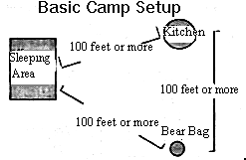Try to plan your day so you arrive at your campsite with sufficient daylight to set up camp. In general, stay at least 200 feet away from streams and lakes. If possible, set up the tarp, cooking area, and bear bag in a triangular pattern with about 100 feet on each side. When in camp, try to minimize your impact and do not leave anything behind.

1. Do not build trenches around tarps, cut live branches, or pull up plants to make your campsite more comfortable
2. Because of the heavy use of the cooking area, put your stove in the most durable part of the campsite; large rocks are ideal
3. Remove hiking boots and put on soft-soled shoes to reduce damage to vegetation and soil
4. Remember that all garbage needs to be packed out with you including tampons, sanitary pads, and toilet paper. Plastic bags are available at base camp and resupply for this purpose. Pack tampons and sanitary pads out with tea bags to absorb the odor. When possible, try to pack out any trash found at campsites.

*3.1.2:* *Knots*

Knots are the tools used to hang bear bags and tension tarps, but their value goes far beyond their direct, practical uses. Listed below are the five most common camp knots taught on LandSea, their uses, and the methods for tying them:

***Clove hitch*** – Use the clove hitch knot to tie your bear bag to the middle of the rope. This is a sturdy knot that is easy to release. To begin:

1. Make one loop with the two ends of the rope crossing on top
2. Make a second loop with the two ends of the rope crossing on the bottom
3. Place the second loop over the first
4. Place the top of the bear bag between the loops
5. Pull on both sides of the rope

***Trucker’s hitch*** – The trucker’s hitch is a strong, easily adjustable knot. It is ideal for setting up a tarp. Consult the following images to learn how to tie the trucker’s hitch.

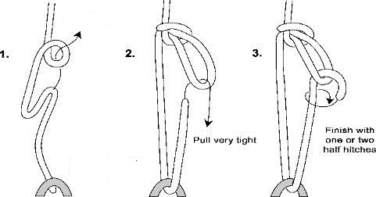

***Half hitch*** – The half hitch is not secure knot when used independently, but is often used to back up other knots. Two half hitches stacked on top of each other can be used as a quick and easy tie off. To tie a half hitch:

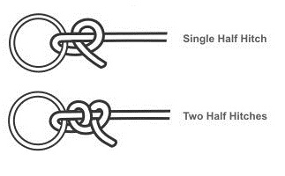

***Bowline*** – The bowline is a knot that is known for its strength and the fact that it rarely slips. It is often used as a stationary tie-off that can hold large loads. Consult the following images to learn how to tie the bowline:

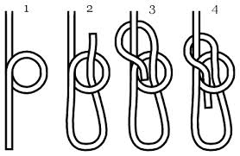

***Taut-line hitch*** – The taut-line hitch is known for its adjustability. It is more easily adjustable than the trucker’s hitch, but does not have the same strength and can slip over time. Consult the following images to learn how to tie the taut-line hitch:

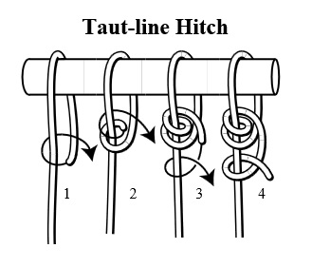

*3.1.3: Putting up a tarp*

There are many good methods for setting up a tarp. Which method is best depends on the context. It depends on quality of ground, available tie-off points, total area needed to shelter the whole group, and a number of other factors. Because of this variability this section will not address specific methods, but will rather discuss general tarp principles. The following steps are the necessities of tarp set-up.

1. **Look Down.** Find a flat spot without too many roots or rocks that can house your entire group. Be sure to think about the slope of the surrounding ground and where water would flow in the case of heavy rain. Your tarp can protect you from water above, but only good planning can protect you from water below.
2. **Look Up.** Be sure that you are not setting up your tarp underneath any dead branches or other potential falling hazards. Although the shelter of a well-set-up tarp feels very secure, it doesn’t do much when put up against fifty pounds of dead wood.
3. **Look Around.** Assess your tie-off options. Trees, large rocks, and using ground stakes are all viable options for tying off a tarp.
4. **Consider the wind.** When making your tarp master plan, be sure to consider the direction and strength of the wind. Put the side of the tarp that faces the wind low to the ground to prevent water from entering from the side.
5. **Set it up.** You’re done planning, get that tarp up there! Helpful tarp knots are adjustable knots such as the trucker’s hitch and taut line hitch as well as fixed knots such as the bowline. Refer to the knots section of this chapter for more information.
6. **Tension, Tension, Tension!** Not only is a loose tarp ugly, it is also ineffective. A loose tarp allows water to pool and leaks where puddles form. It is also more vulnerable to wind than a well tensioned tarp. By putting tension in the right places you can create effective run-off routes for water and be prepared for high wind. It is important to remember that given adverse weather tarps will lose tension over time. Re-tightening tarp lines just before going to sleep is a good idea, and waking up to adjust and tighten lines during the night is occasionally necessary.

For examples of specific tarp set-ups, review the figures below.

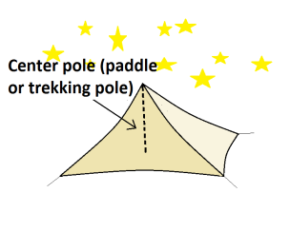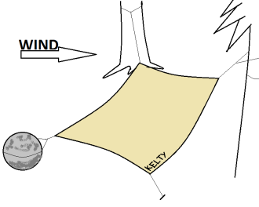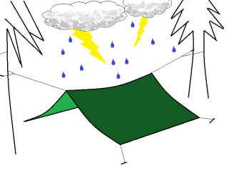

3.2: Cooking

*3.2.1: Backcountry Kitchen*

It is important to alternate responsibilities. Try to avoid stereotypes and patterns, such as the men putting up the bear bag and the women cooking.

**Location of the kitchen**

When looking for a place to cook, find a flat, even place preferably consisting of something that will not burn, such as rock. Place your cooking area 100 feet away from both your sleeping area and your bear bag.

**Cleaning up**

Attempt to cook only as much food as you will eat. However, if there are leftovers, you have two options: 1) pack it out or 2) save it for another meal. In either case, the food must go in the bear bag for the night.

When cleaning up, do not wash dishes directly in the lakes or streams. Instead, wash dishes away from the water. Dig a cat hole (100 feet from water) for the rinse water and soap. Pine needles are an excellent abrasive substance with which you can clean pots and pans. Make sure your dishes are clean so animals are not attracted to the smell of leftover food particles.

*3.2.2: Stoves*

The LandSea program primarily uses Trangia stoves. Trangia stoves burn methylated spirits (alcohol) and do not require any pumping or priming except in cold weather.

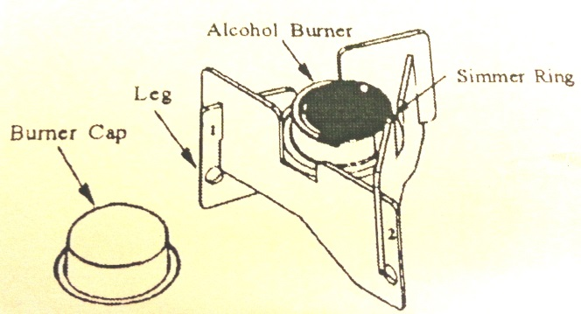**Lighting the Trangia**

1. Position the legs with the hold in the lower right corner of each leg, then slide the leg slots together to form tripod.
2. 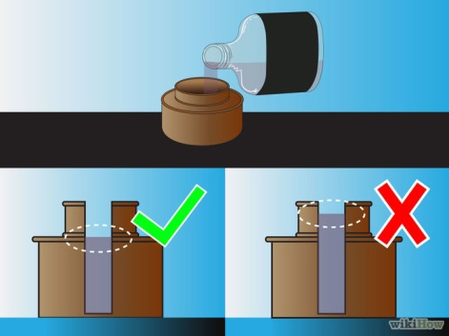Place burner inside tripod, resting the edge of the burner on the “U” cutout of the legs.
3. Remove the lid off the brass burner and pour in denatured alcohol. Never fill the burner more than 2/3 of the way full!
4. Make sure the screw on burner cap is not on the burner. Ignite the fuel.

**Trangia tips**

* *To increase efficiency:* Use foil windscreen.
* *To adjust the flame:* Place the simmer ring on the burner with the brown cover adjusted to the desired opening. Turn the cover in for slower burning.
* *To extinguish:* Put the simmer ring on the burner with the cover closed. The flame will die out after a few seconds.
* *To refill:* Never refill the burner until the flame is out. Alcohol flame can be difficult to see in the daylight. Check for heat from burner and let it cool before refilling.
* *To store:* Wait for the burner to cool, then screw on the burner cap. If you are transporting or storing fuel inside the burner, ensure the cap is on securely and there are no leaks.

# **Safety**

It is important that everyone understands how the stoves work before lighting them. Use common sense when around the stoves and fire. Do not overfill the stoves and never refill a stove until it is cool. Stoves should be filled away from the area in which you are using it. The fuel bottles should not be located near the stoves. Use the best and cleanest fuel available. Keep your stove clean. Avoid setting it in sand. Place stoves on flat, durable surfaces. Do not lean directly over the stoves when cooking or lighting the stoves.

3.3: Water Treatment

*3.3.2: LandSea Method (Polar Pure)*

LandSea uses Polar Pure, a crystalline iodination method to purify water collected from natural water sources.

**1. Prepare solution:** Fill your Polar Pure bottle with water, cap tightly, shake side to side briefly, and set aside. Solution will be ready to use in one hour. The bottle cap of your Polar Pure bottle is used to measure the amount of Polar Pure solution needed to treat the water in your quart/liter bottle of water. We recommend always keeping your bottle filled with water to help decrease vaporization of the iodine and so that it will be ready to use when needed.

**2. Treat your water:** When your Polar Pure solution is ready, pour the required capfuls of solution into your quart/liter container(s) of water. A green dot on the dosage table on the side of the Polar Pure bottle indicates the number of capfuls of solution required for treatment.

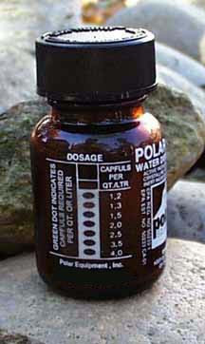Tightly cap your quart/liter bottle of water, shake gently to mix and let stand for 20 minutes. Water to be treated that is colder than 68° F will require longer treatment time.

**3. Refill your Polar Pure bottle:** Refill your Polar Pure bottle with water, shake side to side, and tightly cap. The solution will be ready to use again in one hour. It is best to keep your bottle filled and ready to use at all times.

3.4: Nutrition

*3.4.1: Guidelines*

**Calories**

The strenuous activities of backpacking and canoeing place a high demand on your body’s energy resources. The average daily requirements for a person doing light work on a normal day at home are between 1800-2200 calories. That same person needs between 3700-5000 calories on the trail. The energy equivalent of 5000 calories is 250 packs of life savers, 70 cookies or 4 loaves of bread a day. It is important to eat and eat often. It is also important to eat the right kinds of foods. The main foods that you should eat are carbohydrates, fats and proteins.

Encourage groups to take enough food. Especially after the first few days, they could be surprised by how hungry they become. Let the group come to a consensus if they want to bring food items that will not be consumed by everyone, but remind them that they need to be sensitive to the dietary needs and preferences of the whole patrol. It is important to consume enough carbohydrates, protein, and fat and maintain the high daily caloric demands of wilderness travel.

***Carbohydrates*** (4 calories/gram released quickly)—starches and sugars are digested and absorbed the quickest—normally between 1-2 hours after eating. Carbohydrates should make up about 50% of a person’s daily caloric intake.

***Proteins*** (4 calories/gram released quickly)—contain as much energy as carbohydrates but require 3-4 hours to completely metabolize. Proteins are the essential building blocks of all tissue. Proteins should make up about 25% of your caloric intake while in the backcountry.

***Fats*** (9 calories/gram released slowly)—contain more than twice as much energy per pound as either carbohydrates or proteins, and require 3-4 hours to entirely metabolize. It is recommended that about 25% of your daily intake be fats. Fats take longer to break down than carbohydrates, and thus are a better source of long term energy. For example, adding a spoonful of butter to a cup of hot chocolate will increase the caloric intake. Plus, it will help keep you warm all night.

**Personal Condition and Possible Nutritional Solution**

*Low motivation (chronic tiredness)*

* Eat more of everything
* Examine other causes (dehydration, illness, poor physical conditioning, nutrient deficiency)

*Low energy on the trail*

* Eat a larger breakfast or one with a balance of carbs and fats
* Eat fewer fats and more carbohydrates during trail breaks
* Drink more water with the trail snacks

*Muscular soreness at the end of the day*

* Eat extra protein with the evening meal

*Sleeping cold at night*

* Eat more fats along with adequate carbohydrates at dinnertime

*3.4.2: Dietary Restrictions*

There are steps that can be taken in all instances of dietary restrictions in order to minimize the risk of health problems and to respect individual dietary preferences. On day zero, leaders will confirm and further discuss dietary restrictions listed on med questionnaires and ask all patrol members for any dietary restrictions that were not listed for any reason. All dietary restrictions should be communicated to the patrol, preferably by the participant themselves, so that each member of the patrol can share responsibility for preventing cross-contamination or making sure there are adequate meal alternatives available.

3.5: Hygiene

*3.5.1: Food*

Contamination is our biggest concern with food safety in the back country. Be sure to clean hands before cooking/eating, and always use utensils to handle food, especially when serving from common food containers (e.g. do not put your fingers in the peanut butter jar, especially if you are sharing with others). Be vigilant about any food allergies in your patrol. One helpful strategy is to designate a specific utensil that is only to be used with the food allergen, and do not expose any communal utensils or dishes that the allergic person could potentially use. In other words: wash hands, dishes, and utensils often and do not cross-contaminate. For more information on dealing with food allergies, see section 3.5.1.

Food contamination by animals is another concern. If bowls or pots are left out overnight (sometimes even during the day), it is likely that critters will crawl in and sniff around, bringing with them the risk of disease transmission. There are many potential diseases that can be transmitted by animals and their droppings. One disease rodents could carry is Hantavirus, which is fatal in 1/3 of cases, though it is uncommon in the eastern United States. Any food in a package that has been opened/chewed through by an animal should be considered contaminated and discarded immediately. If an animal touches anything that is used for eating or cooking, it should be thoroughly cleaned with a dilute bleach solution before it is used again.

*3.5.2: Personal*

It is important to try and keep yourself clean while you’re travelling in the back country. There are many opportunities to access water throughout the program where you can swim to get clean, spot clean your body, and wash your clothes. It’s important to completely dry off the groin region and feet before continuing to hike to avoid blisters on feet, chafing on thighs or near the groin, or trench foot.

To bathe, rinse yourself in the water and then go onto shore, at least 150 feet away from the water and lather up. Rinse yourself off where you lathered up, away from the water. A good way to rinse off is with water either in a water bottle or in a pot. Dig a cat hole and bury the soapy water. Biodegradable soaps are only to be used in the woods, and deposited into the soil, never into a body of water.

**Vaginal Hygiene**

Vagina-havers can develop a yeast infection when the normal balance of vaginal bacteria is disrupted or infected, something that is much more likely to happen in the back country when wearing the same damp, sweaty clothes for long periods of time (a yeast infection is a type of vaginitis that we can treat with fluconazole on trail). We can prevent yeast infections by cleaning the area with water frequently and keeping it as dry as possible by changing underwear at least once a day.

**Hand washing**

Hand washing is of the utmost importance in the outdoors. Hands should be washed carefully and with soap each time you use a latrine or box and always before handling or preparing food. Scrub your hands thoroughly, clean under your fingernails. Hand sanitizer may also be used. Some of the most common ailments for backcountry travelers are gastrointestinal disorders transmitted through food by bacteria from dirty hands.

**Washing clothes**

Rinsing and then wringing your clothes in the water is an adequate way to clean clothes. Do not use soap on clothes because it is difficult to rinse all soap and residue out of clothes. This residue can cause skin irritations and rashes, as well as leave lots of suds behind in the woods.

*3.5.3: Backcountry bathroom*

**Cat holes**

Cat holes are backcountry receptacles for biodegradable waste. This waste includes biodegradable soap, human waste, natural toilet paper (leaves, moss, and sticks, for example), and liquid food wastes. Cat holes should be 6-8 inches deep, at least 200 feet from water and 100-200 feet from trail. They can be dug with a rock, stick, heel of a boot, or trowel. LandSea brings loo kits on the program, containing toilet paper, a trowel, and hand sanitizer. Toilet paper must be packed out so each member of a patrol will carry a bag for used toilet paper. Remember, the trowel is used to touch only one brown substance – dirt!

3.6: Preventative First Aid

*3.6.1: Blisters/Foot Care*

* Be aware of your feet. Have they been cold, wet or sore in the past day?Check feet during breaks. Treat at the first sign of rubbing.
* Role Model! Even if you don’t have a hot spot, you can take your boots off to model good EB and blister prevention.
* Avoid walking barefoot.
* Keep feet clean and toenails trimmed.
* Dry your feet before going to bed to promote good circulation, sensation, skin integrity and to avoid non-freezing cold injury.

*3.6.2: Sunburn*

* Cover up! Encourage covering exposed skin/eyes with clothing, hats and sunglasses
* Wear sunscreen. Apply & Re-apply
* Stay in the shade when possible

*3.6.3: Athletic Injuries*

* Use proper boot lacing and hiking techniques
* Warm up muscles, stretch and be attentive while walking
* Avoid fatigue and haste while hiking, especially with heavy packs

*3.6.4: Hypothermia, Frostbite, Non-Freezing Cold Injury*

* Stay warm and dry
* Change out of wet clothing, use proper layers, and stay active during cold weather

*3.6.5: Heat Injury/Hydration*

* Pre-hydrate—drink water before you begin a day of strenuous activity
* Drink small amounts often
* Drink cool water if possible—it is more easily absorbed into your body
* Keep a bottle of water easily accessible to remind you to keep hydrated
* Make drinking a habit; thirst is a reliable indicator to drink more water

**Chapter 4: Navigation**

4.1: Navigation

*4.1.1: Topographic Maps*

**Contour Lines**

Contour lines are used to depict the 3-dimensional character of terrain on a 2-dimensional map. Each contour line on a topographical map represents an equal measure of elevation above sea level. Contour lines are cumulative. Therefore, a region of a map with many contour lines drawn close together represents a steep slope.

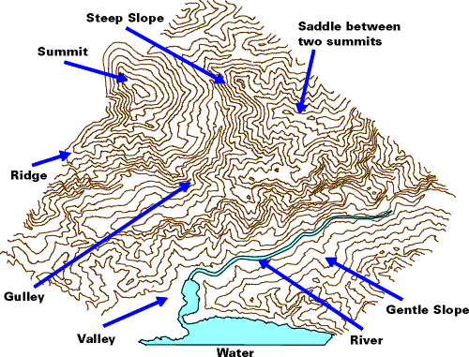The map legend will indicate the contour interval—the change in elevation between each contour line (usually given in feet or meters). A variety of surface features can be identified using contour lines.

*Figure 4.1: Topographic representation of mountainous terrain using contour lines.*

|  |  |
| --- | --- |
| **Table: Common surface features using contour lines** | |
| ***Feature*** | ***Representation with Contour Lines*** |
| Steep slope | Narrow spacing between contour lines. |
| Gentle slope | Wide spacing between contour lines. |
| Valleys | Contour lines form a V pointing uphill. These V's also indicate a drainage path, which could be a stream or river. |
| Ridges | Contour lines form a V pointing downhill. |
| Summits | Contour lines form concentric circles. |
| Depressions | Circular contour lines radiate to the center. |

**Map Scales: Measuring Distance**

Distances can be approximated using a map’s scale. When measuring distances, it is important to keep in mind that hiking trails aren’t straight, and that map scales don’t account for changes in elevation. To more accurately measure a distance, use a string or flexible wire to trace a route, then straighten to measure against the map scale. Or, you may simply approximate a distance by estimating how many of the map scales are held within a route. Remember that features of a trail, such as switchbacks, may add a lot of distance to a route.

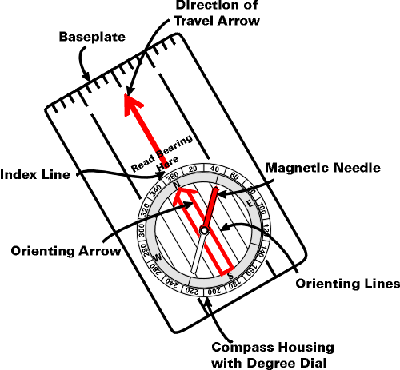

*4.1.2: Compass and Orienteering*

Navigation in the wilderness means knowing your starting point, your destination, and your route to get there. It also means knowing your equipment and how to use it and constantly re-checking your position.

**Using the Compass**

A compass is a magnetic needle that floats on a pivot point. The needle orients itself with earth’s magnetic field. The basic orienteering compass is composed of the following parts:

* Baseplate
* Straight edge and ruler
* Direction of travel arrow
* Compass housing with 360° markings
* North label
* Index line
* Orienting arrow
* Magnetic needle (north end is red)

**The Two Norths**

* ***True North***—also known as Geographic North or Map North—is marked as H on a topographic map. It is the geographic north pole where all longitude lines meet. Maps are drawn with true north directly at the top. Unfortunately for the wilderness traveler, Earth’s magnetic field does not align with True North. Instead, your compass points toward a different location: Magnetic North.
* ***Magnetic North*** is Earth’s magnetic pole. Earth’s magnetic field is inclined about 11° from Earth’s axis of rotation. Further, because Earth’s core is molten, the magnetic field is always shifting slightly.[2] Your compass, of course, aligns itself with Magnetic North, rather than True North. For this reason, orienteers must account for the difference between the two Norths using declination.

**Declination**

Maps are drawn in relation to True North. Compasses point to Magnetic North. This presents a problem when trying to navigate with map and compass. The difference between Magnetic and True North varies according to location on the globe. Therefore, it is important to know a map’s declination before attempting to orienteer. Figure 4.3 illustrates how declination changes in the United States. Most topographic maps will indicate their declination. In the Adirondacks, declination is around 14°W. This means your compass will point toward true north if you rotate the casing 13° left, or counter-clockwise.

Generally speaking, you will find the map declination on the lower portion of the map/border—separated from the map legend – or on the map compass itself. If no declination is given, it should be safe to assume that the map internally accounts for declination, and thus is oriented to magnetic North.

*Figure 4.2: Declination lines for the United States.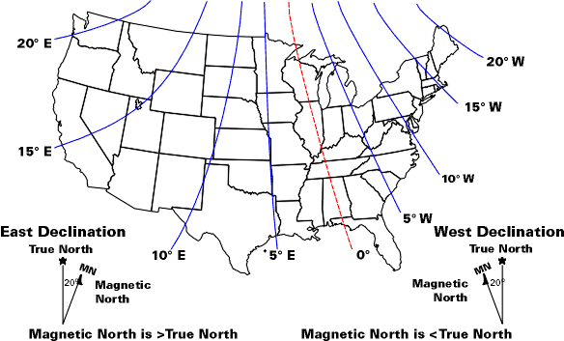*

**Bearings**

Taking bearings is a common use of the compass. A bearing is an angle measured clockwise from north to some point either on a map or in real life. Bearings are used to accurately assess position (i.e. “get your bearings”) or to travel to a destination. If you are working from your map, it is called a map bearing and the angle you are measuring is the angle measured clockwise from true north on your map to this other point on the map.

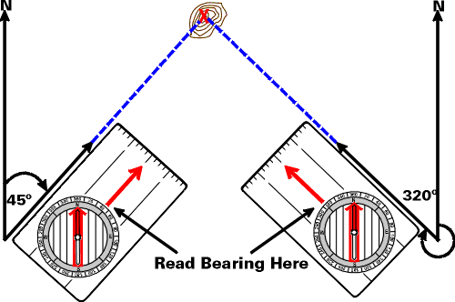

*Figure 4.3. Taking a map bearing from True North.*

**Map Bearings & Magnetic Bearings**

Maps display True North, not Magnetic North. Therefore, when taking a bearing from a map and using it in the field, you must correct for declination. In the Adirondacks, this means *subtracting* the declination from the map bearing.

The opposite is also true. When taking a bearing in the *field* (against Magnetic North) and transferring it to the *map* (which sometimes use True North), you must account for declination. In the Adirondacks, this means *adding* the declination to the magnetic bearing.

This can get confusing. Use the following table to keep things straight. Keep in mind that declination in the Adirondacks is *West*.

Remembering to account for declination is a valuable skill, but frankly, it is a pain. You can eliminate the need to correct for declination if you use your compass to orient the map each time you consult it. As long as the map is oriented with respect to magnetic north, any bearings you take from map to field or field to map will be the same. Orienting the map will honestly make your life much easier, but it’s important to remember to re-orient with your compass each time you use the map.

**Check Your Position Regularly**

Keep your map and compass handy and make it a habit to refer to them every hour or so to track and verify your position. When hiking, keep track of your starting time, rest breaks, and pace. This will not only keep you from getting lost, it will also give you an idea of how far you have traveled and how far (and how long) you have to go.

**Orienting the Map**

It is easiest to read a map if the map is oriented to the surrounding landscape. There are two ways to orient your map: by eye, using terrain features, or with your compass.

*Orienting the Map Using Land Features*

Lay the map on the ground or hold it horizontally. Rotate the map until recognized terrain features roughly align with their representations on the map. If there is a peak to your right, there should be a peak to your right on the map.

*Orienting the Map Using a Compass*

1. Identify declination from your map.

* In the Adirondacks, declination is 14°W, meaning magnetic north is west of true north.

1. Add 14° to your compass by rotating the housing counter-clockwise.

* If you align the orienting arrow with the magnetic needle, the direction of travel arrow now points to True North.

1. Place the compass on the map.
2. Align the edge of the baseplate with map lines running north/south, or with the east or west edge of the map.
3. Holding the compass in position on the map, rotate the map until the magnetic needle is aligned with the orienting arrow.

IF:

* the baseplate is still aligned with north/south map lines,
* the direction of travel arrow points toward True North on the map, and
* the compass is correctly aligned to account for declination,

THEN:

1. The map is properly oriented.

**Identify terrain features**

With the map oriented, look around for prominent features landscape features such as mountains, valleys, lakes, rivers, etc. Make a mental note of the geographical features you will be traveling along and seeing during the day. If you keep the terrain in your mind, you will usually have a general idea of where you are just by looking around.

**Chapter 5: Hiking**

5.1: Hiking Locations

*5.1.1: Dix Mountain & Giant Mountain Wilderness Areas*

The Dix Mountain Wilderness Area forms part of a complex of Wilderness Areas that collectively comprise one of the best known recreation areas in the Adirondack Park: the high peaks region. The Dix Mountain Wilderness Area is characterized by rough, rocky terrain and towering peaks, some over 4,000 feet in elevation. In recent years there have been several small landslides on the near vertical slopes of the high peaks. These landslides have left the mountains scarred with enormous slabs of bare rock.

The trail system used by LandSea is a combination of marked, maintained trails and unmarked, unmaintained hunting trails. By combining these trails into a complete network, it is possible to traverse through the entire section.

*5.1.2: Cranberry Lake 50*

The Cranberry Lake 50 is, as its name implies, a 50-mile hiking loop that circumnavigates Cranberry Lake in the Northwestern Adirondacks. The trail traverses the Five Ponds Wilderness and Cranberry Lake Wild Forest, which both offer countless opportunities for hiking, paddling, fishing, skiing, and camping.

Cranberry Lake is known for the ecological diversity it offers. An abundance of wild plant and animal life thrives in the area. Perhaps the most notable point of ecological interest is the old-growth forest. The relatively late settlement of Cranberry Lake accounts for the largest contiguous section of old-growth forest left standing east of the Mississippi River. In some areas the trees have been standing for as long as 400 years!

5.2: Backpacking Equipment

*5.2.1: Backpacks*

Properly sizing, adjusting, and packing a hiking backpack are very important skills for traveling comfortably in the backcountry.

**Sizing a pack**

* Ideally, 80% of a backpack’s weight should be distributed to the hips, and only 20% to the shoulders. For this reason, the torso length of a backpack is its most important dimension to consider when participants are given program backpacks.
* Most packs have mechanisms for adjusting torso length.
* Be sure to loosen the pack’s adjustment straps entirely before packing, and then tighten them once you’re finished.

**Packing a pack**

* Generally, the heaviest items in a pack should be near the bottom, close to the hiker’s spine, and centered in the middle of the back. Keeping weight low maintains a low center of gravity. Keeping weight close to your back reduces strain. And keeping weight centered provides balance.
* It is important to balance a pack’s weight laterally. Try to match the weight of items on each side of the pack, and avoid hanging items on the outside of the pack. These items are likely to be damaged, and they swing from side to side on trail, throwing of the pack’s balance.
* Rocks before sand—pack large, solid items (sleeping bag, stove, food bag, etc.) first, then stuff smaller, moldable items (e.g. clothing, fleece and jackets) last. This will allow more efficient use of space, and it will provide a tighter, more secure pack.
* The sleeping bag is almost always on the bottom of the pack.
* Make an effort to keep items you need during the day accessible (i.e. near the top of the pack, in the lid, or in an accessible exterior pocket).

**Putting on a heavy pack**

There are several ways to get a heavy pack onto your shoulders. Use a ledge or a downed log, have a friend hold the pack, or use these helpful tips to don it yourself:

1. Loosen the shoulder straps slightly.
2. Grab one shoulder strap with each hand and lift the pack onto your bent right knee.
3. From your knee, steady the pack with your left hand and put your right arm and shoulder through the right-hand shoulder strap.
4. Swing the weight of the pack onto the center of your back, leaning forward slightly.
5. Place your left arm through the left shoulder strap.
6. Fasten and tighten the hip belt.
7. Tighten the shoulder straps.

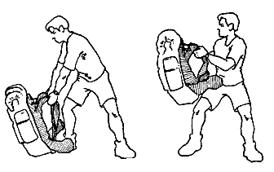

5.3: Hiking Technical Skills

*5.3.1: Hiking Technical Skills*

When hiking, it is a patrol’s goal to move safely, efficiently, with minimal impact to the natural environment, and with minimal conflict between group members. Here are some guidelines to keep in mind while your group is hiking:

* ***Stretch***– Remember, hiking is a sport. To prevent torn and tight muscles, and to keep hiking comfortably for weeks at a time, it is important to stretch your hamstrings, calves, feet, shoulders, and back muscles before hiking.
* ***Stay on the marked trail*** – Trails are often marked with cairns (small piles of rocks), markers on trees, or arrows at intersections. Leaving the marked trail without the proper preparation is a good way to get lost.
* ***Hike single file*** – Trails are well-defined because they are well-used. Walking two-by-two or walking around obstacles (such as mud) widens the trail, and encourages later hikers to further widen the trail. It’s a vicious cycle that leaves a trace on the environment.
* ***Distance yourself slightly*** - When hiking behind a person, maintain a reasonable distance. Walking too closely means: i) you can’t stop when the front hiker stops suddenly, ii) you will be whacked by branches the front hiker pushes out of her way, and iii) you will not be able to clearly see the terrain you are crossing. Try to keep between ten and twenty feet of spacing between hikers.
* ***Pace*** – It is difficult to find the right pace for a group of people. The ideal hiking pace can be maintained all day with short rests every hour or so. If the patrol needs to slow down or stop more often than every hour, the pace is too fast. Keep in mind that this pace must be acceptable for the slowest member of the patrol.
* ***Don’t rubberband*** – Rubberbanding is the term for when hikers don’t stay together on the trail. The group’s pace is that of the slowest hiker. It is important that the patrol stay together for several reasons. Rubberbanding can have many results, from interpersonal conflict within the patrol, to serious safety issues and getting lost.
* ***Rest*** – The patrol should rest every hour or two, whether the participants think they need to or not. As the days wear on, it’s common for patrols to take progressively longer rests and progressively shorter hikes. Some patrols choose to time their marches and rests to keep themselves consistent and accountable.
* ***Drink and eat on trail*** – Remember to eat before you’re hungry and drink before you’re thirsty. If you, as the leader, are tired, hungry, thirsty, or cold, it is certain that your participants are as well—probably much more so. Everyone should be drinking copious amounts of water while hiking. But keep in mind that some participants will need to eat more or less than others. Encourage participants to make use of their individual GORP bags during hiking breaks.
* ***Going uphill*** – When going up a steep incline, stand up straight and lean forward slightly. Keep your foot flat on the ground as long as you can before rising onto your toes and lifting the foot forward. This makes use of your quadriceps, instead of relying entirely on calf muscles. Try to breathe in rhythm with your footfalls.
* ***Going downhill*** – Hiking down a steep decline is more difficult than hiking uphill. Go slowly and take small steps to prevent accidents, injuries, and undue strain on your knees.

**Chapter 6: Canoeing**

6.1: Canoeing Locations

The canoeing portions of LandSea occur both on lakes and rivers. Some water areas are primitive and don’t allow motorboats, while others have frequent motorboat access (especially on the weekends). Canoe carries, or portages, occur between lakes and around obstacles—waterfalls, rapids, dams and other human-made obstacles. The rivers are fairly calm with quick moving flat water and occasional ripples.

6.2: Canoeing Equipment

*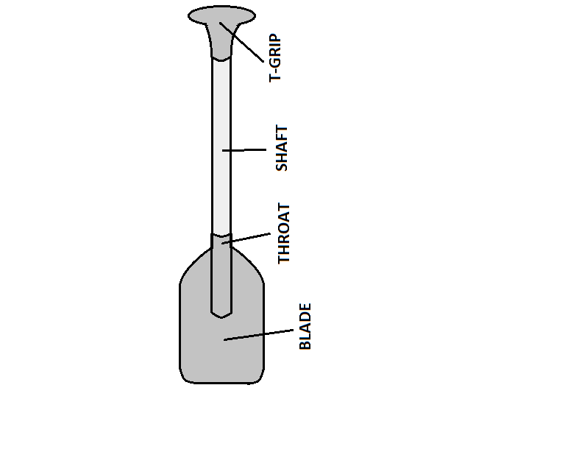6.2.1: Canoe Anatomy* 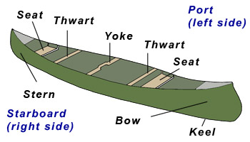

Gunwale

*6.2.2: Paddle Anatomy*

*6.2.3: Personal Flotation Device (PFD)*

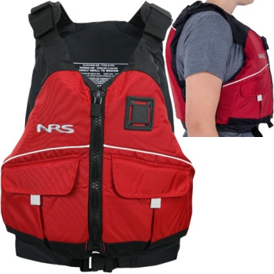**PFDs should be fit so that...**

* All zippers can zip
* All buckles can clasp
* PFD is snug, but paddler can still breathe
* When pulling up on the shoulder straps, straps do not reach higher than the paddler’s ears

*6.2.4: Equipment Care*

Just like all equipment, canoes should be treated with respect. Canoes on LandSea should be returned at the end of the trip in the same condition that they were received.

**Guidelines for taking care of canoes**

* Don’t leave the canoe partly in and out of the water. Motion from the water and friction from the land will cause wear on the canoe’s hull.
* Never drop the canoe while carrying it. Make certain you have a sure grip and strong footing before attempting to carry a canoe.
* A loaded canoe should never touch land. Always load and unload the canoe while it is floating in the water. Dragging a loaded canoe onto the shore can cause tremendous damage.
* Don’t drag the canoe on shore or on top of rocks.
* Never sit on the yoke. It is not weight-bearing.
* The bottom of the canoe should never touch the ground. The canoe be turned upside down, sitting on its gunwales on land.
* In strong wind, take the canoe up onto land and turn it upside down. In extreme circumstances, tie the canoe down at both ends.
* Be careful not to leave PFDs and/or extra paddles behind. Keep extra paddles with you or assign them to a canoe. Forgotten PFDs and lost paddles create safety concerns and add costs to the program.

*6.2.5: Entering and Exiting the Canoe*

For novice paddlers, entering and exiting the canoe can cause injury, capsize, or damage to equipment. Here are some tips:

* The canoe should be completely in the water when entering or exiting. Be sure the canoe is deep enough not to scratch any subsurface rocks.
* Don’t be afraid to get your feet wet. Most injuries and damaged gear result from participants attempting to enter or exit the canoe while keeping their feet dry.
* One paddler enters or exits at a time. The other paddler holds the boat steady by holding the gunwales while standing outside the canoe or by using the T-grip of a paddle to steady from inside the boat.
* The entering or exiting paddler should keep the boat balanced by keeping a hand on *both* gunwales and keeping their foot centered in the bottom of the boat while entering or exiting.

6.3: Paddle Strokes

Tandem canoeing requires two paddlers: a stern paddler and a bow paddler. The bow paddler’s primary responsibility is forward momentum. The stern paddler’s primary responsibility is to steer the canoe. Secondarily, they contribute to the boat’s forward momentum.

When paddling, be sure to engage your abdominals and back muscles. Try to rely more heavily on these large core muscles than on your shoulders. A strong paddler creates a “box” with his or her body and the paddle, the four corners of which are two shoulders and two hands. This “box” should be maintained throughout all strokes.

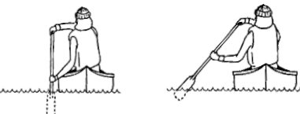

*6.3.1: Anatomy of a Canoe Stroke*

***Correct***

***Incorrect***

**Phase 1**—***Catch:*** Wind your torso into the stroke. Dip your paddle on one side of the boat and “catch” a blade’s worth of water. If placing the blade on the boat’s right side, the right side of your rib cage should be angled toward the bow.

**Phase 2**—***Propulsion/Power:*** Unwind, or rotate your torso as the blade pushes the water behind you. Use core muscles to push past the blade rather than pulling the blade through the water with your arms. This boosts efficiency and reduces fatigue.

**Phase 3**—***Recovery/Release:*** As the paddle pops out of the water, you’re now wound up for the next stroke with the opposite side of your rib cage angled toward the boat’s bow.

*6.3.2: Common paddling strokes*

|  |  |
| --- | --- |
| **Bow** | **Stern** |
| * Forward * Back/Reverse * Hip Draw * Bow Draw * Sweep (forward/reverse) | * Forward * Forward w/Rudder * Forward w/J Stroke * Back/Reverse * Hip Draw * Stern Draw * Stern Pry * Sweep (forward/reverse) |

**Forward stroke**

|  |  |
| --- | --- |
| *Purpose:*   * Used to make the canoe go forward * For the bow paddler, this comprises 90% of all paddle strokes   *Execution:*   * Reach forward with paddle blade; pull paddle through water * Paddle should remain perpendicular to water’s surface for the duration of the stroke, and the entire blade should be submerged * Stroke should be accomplished by rotating their torso, not by pulling with shoulders * Stroke ends when paddle blade passes paddler’s hips * Remove from water and repeat stroke | *:::Desktop:Forward Stroke.png* |

**Forward with J stroke**

|  |  |
| --- | --- |
| *Purpose:*   * To compensate for the canoe’s tendency to turn during the forward stroke and maintain a straight path * Used on flat-water with the intention of paddling straight. Is used as a corrective stroke. * It does not replace the forward stroke but instead supplements it when necessary * Without breaking forward momentum, the J stroke steers the *bow* of the canoe in the direction of the side on which the *stern* paddler is paddling   *Execution:*   * Begin the J stroke as a forward stroke, submerging the blade perpendicular to the surface of the water * As the blade approaches the hip, rotate the T-grip 90° (T-grip thumb will point to the water) * Push out with the shaft hand. Remove the blade from the water. * Repeat when necessary, alternating between J and forward strokes | :::Desktop:Forward w/J (stern).png |

**Forward with rudder stroke**

|  |  |
| --- | --- |
| *Purpose:*   * To adjust the direction of the canoe, to maintain a straight path, or make a harder turn * Depending on the power stroke of the bow canoeist, canoes tend to drift opposite to the side the stern canoeist is paddling on   *Execution:*   * The stern canoeist braces his paddle against (or near) the side gunwale and rotates his paddle outward at an angle, creating a rudder * This movement pulls the canoe harder to the side of the stern canoeist * At the end of a forward stroke, push the water away from the stern of the boat with the blade * More effective in moving water than the J stroke | :::Desktop:Forward w/Rudder (stern).png |

**Forward sweep stroke**

|  |  |
| --- | --- |
| *Purpose:*   * To move the canoe in the opposite direction of the side the paddler is paddling on * A gentle turn   *Execution:*   * Rotate your torso and extend your lower (sweeping) arm forward * Immerse the blade so it is just fully submerged (near your feet) * With your sweeping arm straight, sweep the paddle in a wide arc (180 degrees) towards the rear of the boat while rotating your torso * The nose of the boat will move away from your paddle blade * Keep the paddle low and horizontal * Slice the paddle out of the water before it hits the rear side of your canoe * Do not neglect the latter part of the sweep stroke, as it is very effective | *:::Desktop:Forward Sweep (bow).png:::Desktop:Forward Sweep (stern).png*  ***B***  ***O***  ***W***  ***S***  ***T***  ***E***  ***R***  ***N*** |

**Back/Reverse stroke**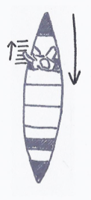

|  |  |
| --- | --- |
| *Purpose:*   * Opposite of the forward stroke * Used as a brake or to reverse the canoe   *Execution:*   * Place blade in water slightly behind hip * Firmly push, moving the paddle forward * When shaft arm is fully extended, remove paddle from water |  |

**Reverse sweep stroke**

|  |  |
| --- | --- |
| *Purpose:*   * To move the canoe in the opposite direction of the side the paddler is paddling on * A gentle turn * Same principles as the Forward Sweep Stroke, just in reverse   *Execution:*   * With your lower (sweeping) arm extended, rotate your body and place your paddle in the water towards the rear of the canoe * Immerse the blade so it is just covered * Using the back of the blade, sweep the paddle forward in a wide arc towards the bow of the boat * Ensure your sweeping arm is flexed slightly, your paddle remains low, and you rotate your body during the stroke | :::Desktop:Reverse Sweep (stern).png:::Desktop:Reverse Sweep (bow).png  ***B***  ***O***  ***W***  ***S***  ***T***  ***E***  ***R***  ***N*** |

**Hip Draw stroke**

|  |  |
| --- | --- |
| *Purpose:*   * To move the canoe sideways (in the same direction of the side of the canoe on which the paddler is paddling) while at a complete stop   *Execution:*   * At the hips, submerge blade in water as far from the canoe as possible * Blade should be fully submerged and perpendicular to water surface with the power face to the canoe * Maintaining perpendicular submerged blade, bring the paddle toward the canoe * Remove paddle from water and repeat * ***TIP***: Underwater recovery—instead of removing the paddle from the water between draws, turn the T-grip 90° to cut through the water as it returns to its initial position in the stroke. This reduces friction and allows rapid repetition of the draw. | :::Desktop:Draw Stroke.png |

6.4: Portaging

Portaging is the extended carrying of a canoe across land between two bodies of water. LandSea uses the two-person portage, which is easiest when participants are wearing their backpacks.

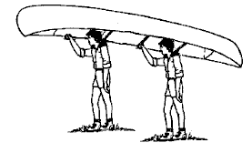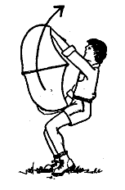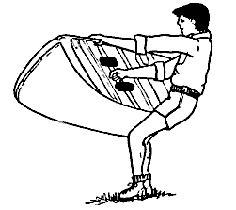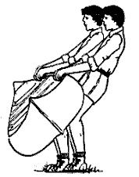

**Beginning a portage (assuming the canoe is on the portagers’ right side as they face the bow of the boat)**

1. Put your pack securely on your back.
2. Secure the PFDs. PFDs can be fastened around thwarts or yokes.
3. One portager is positioned at each canoe seat with both portagers facing the stern of the boat.
4. Both portagers place their left hand on the nearest thwart and their right hands on the left gunwale of the canoe.
5. Together, the two portagers lift the canoe to the hip so it can rest on their left knees.
6. Together, the two portagers lift the canoe over their heads and position themselves under the seats.
7. The portagers gently place the seats of the canoe on top of the lid of their packs.
8. Place paddles in the bow and stern of the boat with the T-grips underneath the bow and stern handles and the blades beneath the seats.
9. Portage.

6.5: River Features

*6.5.1: River Features & Anatomy*

It is important to have a basic understanding of river anatomy and features, especially because features change often based on weather.

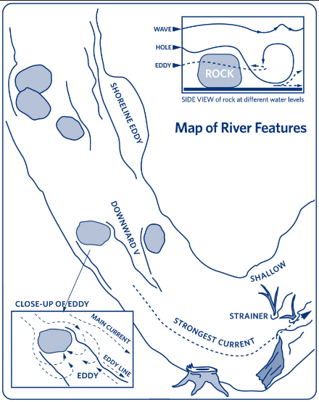

|  |
| --- |
|  |

*6.5.2: River Features Terminology*

* ***Drop and Ledge (horizon line):***There are ledges on rivers which serve as shelves to the next level of the river. Ledges up to a few feet are also called drops because the kayak, canoe, or raft drops to the next level of the river.
* ***Eddy:*** Eddies are formed on the downstream face of an obstruction. Eddies swirl on the horizontal surface of the water. Typically, they are calm spots where the downward movement of water is partially or fully arrested—a nice place to rest or to make one’s way upstream. However, in very powerful water, eddies can have swirling currents which can flip boats, and from which escape can be very difficult.
* ***Flatwater:*** A section of river that contains no rapids. This does not mean that there is no current.
* ***Hole or Hydraulic:*** A hole is a whitewater river feature that forms as the river flows over an obstruction that is usually near or above the surface of the water. As the water pours over that boulder, it causes a recirculation on the other side. This recirculation, or hole, is a frothy and aerated feature that actually flows or pushes upstream. This means that kayaks, canoes, and rafts can actually get stopped and stuck in holes. As the river flows downstream, the hole will be “holding” the paddler as it pushes him or her upstream.
* ***Line:*** Very generically, a line in whitewater is the path that the paddler will want to take through any rapid, wave, hole, or other river feature.
* ***Pillow:*** Pillows are formed when a large flow of water runs into a large obstruction, causing water to “pile up” or “boil” against the face of the obstruction. Pillows normally signal that a rock is not undercut. Pillows are also known as “pressure waves.”
* ***Rapid:*** Whitewater rivers consist of rapids. A rapid is a series of whitewater river features that are strung together. While it could refer to just a wave or two, the word *rapid* generally refers to three or more connected river features in a section of river.
* ***Strainer or Sift:***Strainers are formed when an object blocks the passage of larger objects, but allows the flow of water to continue—like a big food strainer or colander. These objects can be very dangerous because the force of the water will pin an object or body against the strainer and then pile up, pushing it down underwater. For a person caught in this position, it will be difficult or impossible to get to safety, often leading to a fatal outcome. Can include: storm grates, trees that have fallen into a river, bushes on the side of a river, rebar from broken concrete. Strainers occur naturally most often on the outside curves of rivers where the current undermines the shore exposing the roots of trees and causes them to fall into the river.
* ***Undercut rock:*** Undercut rocks are rocks that have been worn down underneath the surface by the river or loose boulders which beam out beyond their resting spots on the riverbed. They can be extremely dangerous features because a person can get trapped underneath them. This is especially true of rocks that are undercut on the upstream side. Here, a boater may become pinned against the rock underwater. Many whitewater deaths have occurred in this fashion. Undercuts sometimes have pillows, but other times the water just flows smoothly under them, which can indicate that the rock is undercut. Undercuts are most common in rivers where the riverbed cuts through sedimentary rocks like limestone rather than igneous rock like granite. In a steep canyon, the side walls of the canyon can also be undercut.
* ***Wave:***Waves are formed in a similar nature to hydraulics and are sometimes considered hydraulics as well. Waves are characterized by the large smooth face on the water rushing down. Sometimes a particularly large wave will also be followed by a “wave train”—a long series of waves. These standing waves can be smooth or (particularly the larger ones) can be breaking waves, also called “whitecaps” or “haystacks.”

**Chapter 7: Climb & Rappel**

7.1: Purpose of Climb & Rappel

The climb, especially a first climb, offers an opportunity for a particularly rich metaphor that compares the climb to life at K or even beyond.

The climb can be difficult for people. Getting “stuck” on the rock may be frustrating; falling can be scary. With a rope and a trusted belayer in place, the climb may become a very exciting and challenging journey.

Many different personality issues come out on the climb and rappel that can help us see ourselves in an unmasked way. This view of ourselves may be interesting and pleasant or it may be scary. Whatever your experience on the climb, your efforts and introspection will be supported.

7.2: Belay School Checklists

*7.2.1: Equipment*

**Helmet**

* Everyone wears a helmet at all times within the designated “Helmet Zone” at the climbing site
* Helmet should be properly fastened and should stay on head even without chinstrap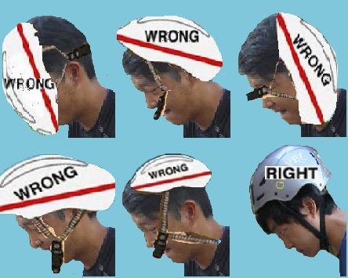

**Harness**

* Harness should be snug enough to hold someone if they were suspended upside-down
* No twisted straps
* Fits above waist
* For climbers, rope follows through same two harness points as belay loop
* For belayers, rope through belay device and locking carabiner; locking carabiner through belay loop with proper orientation

**Belay System**

* The belay system includes the belay device and a locking carabiner
* Be sure that the rope is in the proper orientation: brake end is down
* Be sure that the rope and belay device are threaded through the locking carabiner
* Be sure that the carabiner is locked

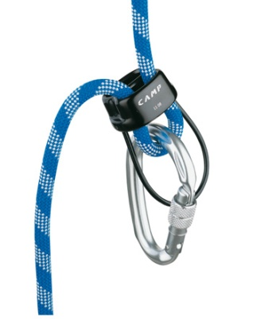

**Knots**

* *Figure 8 follow-through*—check for 5 pairs of parallel line
  + 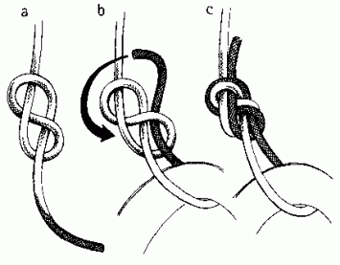
* *Double Fisherman*—check for an ‘X‘ on one side, and one pair of parallel lines on the other

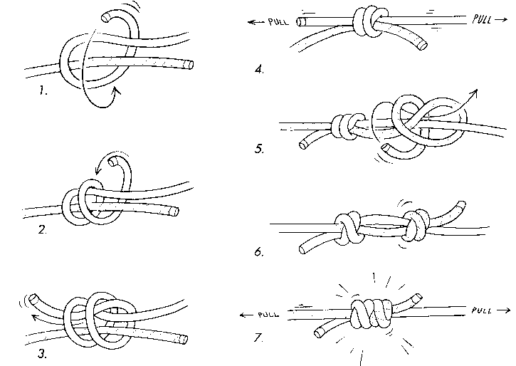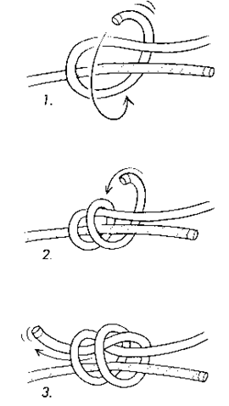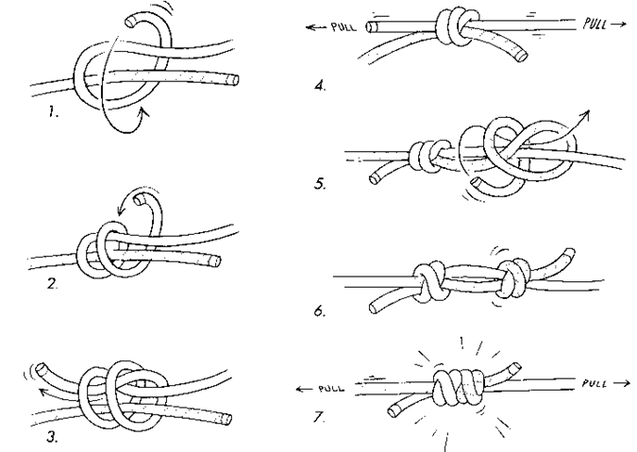

**Rope**

* It is imperative to protect our climbing ropes by keeping them as clean as possible.
  + Do not ever step on top of a climbing rope. When we step on rope, dirt particles are ground in, causing damage to the rope fibers
  + Keep the belayer’s end of the rope protected by laying it on the rope tarp

*7.2.2: Commands*

**Before climbing**

* ***“On Belay” (climber)—***the climber is asking the belayer to enter a ‘contract’ to keep the climber safe while climbing
* ***“Belay On” (belayer)—***belayer is agreeing to the ‘contract.’ Before saying “belay on,” the climber and belayer must check each others’ equipment to be sure that they are set-up correctly
* ***“Climbing” (climber)—***equipment is checked; climber is ready to send
* ***“Climb On” (belayer****)—*equipment is checked; belayer confirms that they are ready to take responsibility for climber’s safety

**While climbing**

* ***“Take” (climber)—***climber signifies that they want to rest; belayer takes slack out of rope, holds the rope in the brake position and responds
* ***“Gotcha” (belayer)—***belayer signifies that they have taken out all slack, the belay device is in the brake position, and is ready for climber to sit back in harness and rest
  + “Take” and “gotcha” should be followed by “climbing” and “climb on” when the climber feels well-rested and ready to climb again
* ***“Falling” (climber)—***if climber feels that they are going to fall, they can yell “falling” to warn the belayer. This will give the belayer the opportunity to prepare for the fall and more safely and effectively catch the climber.

**To be lowered back to the ground**

* ***“Take” (climber)****—*when climber has reached the top of the wall and wants to descend. Belayer removes slack and holds the rope in the brake position through the belay device before responding
* ***“Gotcha” (belayer)—***belayer signifies that they have taken out slack, is holding the rope in the brake position, and is ready to support climber resting in harness
* ***“Ready to Lower” (climber)—***climber is ready to be lowered to the base. Climber must have hands clear of the rock, feet spread apart on the rock, legs extended, and no tangles with the rope to ensure a safe descent
* ***“Lowering” (belayer)—***belayer lets climber know that they are being lowered, begins slowly feeding rope out through belay device
* ***“Off Belay” (climber)****—*upon reaching the base of the climb after descent and standing on solid ground, climber lets belayer know that they are no longer responsible for climber’s safety
* ***“Belay Off” (belayer)****—*belayer affirms that the ‘contract’ has ended and they are no longer responsible. At this point the climber and belayer may begin undoing knots, unlocking carabiner, removing belay device, etc.

*7.2.3: Back Up Belayers*

Backup belayers are used at the climbing site to add another level of redundancy to the system. They take up slack that the belayer lets out (the trailing end of the rope). The purpose of the backup belayer is to brake the belay device to stop the climber‘s fall in the case that the belayer is unable to for any reason (tangled hands, inattention, etc.). The backup belayer must hold the trailing end of the rope close enough to the belayer to effectively lock the belay device in the case of a fall, but give enough slack so as not to affect the belayer‘s technique. The rope between belay device and backup belayer should form a shallow U. The back-up belayer should stand on the same side as the belayer’s brake hand (depends on whether belyar is right-handed or left-handed).

7.3: Climbing & Belaying

*7.3.1: Climber – Tying In*

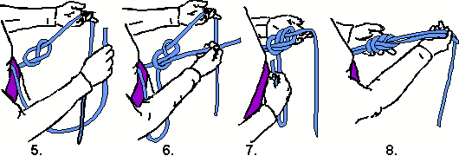

*7.3.2: Belayer – Belaying Steps*

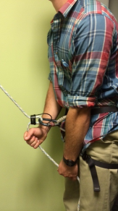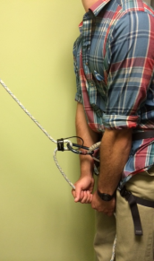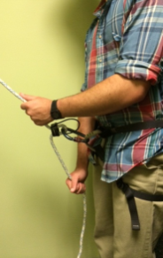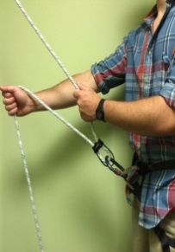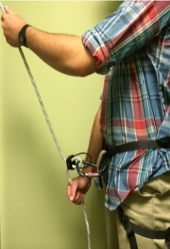

A belay device should remain in ‘brake’ position except when taking out slack. When taking slack out of the line, belay in small, quick ‘circles’ between the nose and waist. A wider range of motion for belaying reduces the belayer’s control and increases the climber’s vulnerability to falls. The bottom hand (dominant hand, brake hand) NEVER comes off the trailing end of the rope. When recovering from taking out slack, the bottom hand must slide back to the belay device, not ‘leapfrog’ over the other hand. When taking a climber, it helps the belayer to provide counterweight. Put the belay device in the brake position and sit back in the harness when breaking a fall or taking a resting climber.

**Chapter 8: Service & Reflection**

8.1: Components of Service & Reflection

Living in society today, it is very rare that individuals are entirely alone, have time to reflect, or give back to the community and land. There are many benefactors and many purposes of Service & Reflection. These include the individual, community and natural area we use in the Adirondacks.

*8.1.1: Components*

The components of Service & Reflection include a choice or combination of:

* Solo experience (one day/one night or two days/two nights)
* Service projects (one or two days)
* Group reflection (one or two evenings)

8.2: Service

*“Everyone can be great, because everyone can serve.”*

*-Martin Luther King, Jr.*

*8.2.1: Purpose*

There are several purposes for the service projects as part of the Service & Reflection component of LandSea. These purposes include: to have participants work together on a tangible project, allow participants the space to reflect in a working environment, to provide an alternative to Solo, and to give back to an area of the Adirondacks that our program uses heavily.

*8.2.2: Projects*

The specific service projects will vary each year based on weather conditions, area needs, and number of people participating. Projects could take place on Massawepie property or on trail, in various wilderness areas. A few likely projects might include:

* General trail maintenance
* Reclaiming of abandoned campsites
* Creating new campsites
* Building bridges, boardwalks, signs
* Trash and old machinery removal
* Painting buildings

*8.2.3: Logistics*

Service projects will occur during the Service & Reflection component of LandSea at the same time as Solo. Participants who choose to do service projects will be busy working during the day with various Leaders, Logistics Leaders, and/or Staff. They might also work with Agency officials or established trail crews.

In the evenings, Participants will participate in-group reflections facilitated by Logistics Leaders and/or Staff.

8.3: Reflection

Reflection can be an integral component of a service-learning experience. The process of reflection can facilitate:

* Transforming an experience into genuine learning about individual values and goals
* Challenging students to connect service activities to objectives and develop higher level thinking and problem solving
* Working against the perpetuation of stereotypes by raising participants’ awareness of social structures surrounding service environments
* Fostering a sense of connection to the community and a deeper awareness of community and environmental needs
* Increasing the likelihood that participants will remain committed to service beyond the end of LandSea

*Adapted from the Colorado State University Writing Center.*

The few ways we facilitate reflection in the Service & Reflection component of LandSea are through both individual and group reflection.

*8.3.1: Individual Reflection*

The most formal piece of individual reflection is a Solo experience (see Solo below). Besides Solo, individual reflection may occur during service projects, during breaks, enjoying a view, or while on trail.

*8.3.2: Group Reflection*

Leaders are encouraged to use group reflection as a tool while on trail; however, the participants who choose to participate in service projects will also participate in group reflection in the evenings facilitated by Logistics Leaders and/or Staff. The techniques used for group reflection will vary, but will be used to draw out experiences from the previous two weeks on trail and the physical service projects and help create connections for the transition back to Kalamazoo College.

8.4: Solo

*8.4.1: Purpose of Solo*

One of the purposes of solo is to allow the participants to reflect over their experiences on LandSea and in their lives. Silence should be enforced so that everyone has the opportunity to reflect if they choose. Individuals are placed within a small, well-defined space with access to water and hopefully a perception of aloneness—not able to observe others or hear leaders. Fasting is an optional component of a solo experience.

*8.4.2: Location & Timing*

Solo sites are situated around lakes and ponds at the Massawepie basecamp. Each year solo sites vary; while you are out on trail, logistic leaders and staff will choose and flag solo sites.

# **Chapter 9: Expedition Behavior**

9.1: Expedition Behavior

Expedition behavior is the simple idea that in a group on trail, standards of behavior are different from—and usually more strict than—standards of behavior in the front country.

In a backcountry setting, the stakes are higher in terms of both physical and emotional safety. The behavior of individuals in a group can have a profound effect on group dynamics and even on the safety on the expedition.

Expedition behavior may be defined by the patrol in a Full Value Contract (see page 55) and every group member is responsible for exhibiting good expedition behavior.

A guiding principle of all expedition behavior is that each individual is responsible for the success—physically, emotionally, and otherwise—of the expedition. Good expedition behavior requires that participants are self-aware and conscious of the needs of their group.

**Suggestions for expedition behavior**

* Serve the mission and goals of the group
* Be as concerned for others as you are for yourself
* Treat everyone with dignity and respect
* Support leadership and growth in everyone
* Respect people you encounter, not just the other students on the course
* Be kind and openhearted
* Do your share and stay organized
* Help others, but don’t routinely do their work
* Model integrity by being honest and accountable
* Say yes and deliver, or say no clearly if you cannot or will not do something
* Resolve conflict in a productive manner
* Be a thoughtful, contributing member of a team

*9.1.1: Full Value Contract*

The full value contract is a strategy for setting standards and behavioral expectations for all group members.

Setting standards for the expedition allows members of a patrol to hold each other accountable to expectations agreed upon at the beginning of the expedition.

There are many different ways to create a full value contract.  They are often most successful when drafted with input from all participants. By facilitating a discussion about positive behaviors and expectations, leaders can not only establish standards and accountability, but also get participants thinking about positive ways to engage with the patrol and the experience.

## *9.1.2: Challenge by Choice*

An important principle in adventure education is the notion that each student sets their own goals and definition of success during program activities. This principle has been summed up by organizations as “challenge by choice”, urging instructors to help students define personal goals that are meaningful and realistic as a pathway to accepting varying levels of challenge that are appropriate to achieving those goals.

Brain research has shown that the brain perceives information in one of three ways: useful information (tunes in), not useful (tunes out), and threatening (shuts down). Challenging situations are often perceived as threatening if the individual is not invested in the experience and the challenge is greater than they feel prepared for. In order for productive learning environments to be cultivated, students *must* be given time to develop personal goals, cultivate meaning in experiences, and become invested in outcomes in order to accept and feel prepared for challenging situations.

On trail, this may manifest itself with an individual choosing varying levels of participation in activities. The focus is on individual growth rather than benchmarking achievements in comparison to others. Climb & Rappel and Service & Reflection are two obvious areas of the program where there is a high level of opportunity for individuals to make decisions regarding personal involvement, but more group-centered activities—choosing rest days, summit attempts, camp locations, taking on leadership roles within the group, sharing personal information with group members, and deciding how long to paddle or hike each day—require varying amounts of challenge where leaders can have a part in helping to facilitate individual choice and decision-making and help group members feel comfortable sharing those needs or desires with the group.

## *9.1.3: Creating a Supportive Learning Environment*

A supportive learning environment is essential to a high-functioning LandSea patrol. In a healthy group with a supportive learning environment, participants:

* Maintain a separate personal identity
* Maintain individual responsibility
* Function well with others
* Feel a sense of inclusion
* Accomplish tasks in an atmosphere of mutual respect and trust

*Mitten, Denise (1999): Leadership for Community Building: Adventure Programming: 254-261.*

**Cultural competence**

“Cultural competence” refers to a set of skills, knowledge and attitudes which enhance an individual’s:

1. Awareness of their own assumptions and values as well as other prevailing attitudes toward culture, both domestically and internationally
2. Understanding of and respect for other’s values, beliefs, and expectations
3. Ability to adapt their interactions to be more congruent with other’s expectations and preferences

**Power of language**

Language we use has subtext that sends messages about our feelings about others. By using and supporting more inclusive language, we can help society develop more inclusive values. Inclusive language isn’t about accommodating other people’s whims; it is about engaging them in conversation without insulting them, excluding them, or creating other roadblocks to healthy communication. On the chart below are a few types of exclusionary language that we should be wary of:

|  |  |
| --- | --- |
| *Jargon* | Language also only works if people hearing it actually understand it. Jargon like evac, eval, LNT, StuDev and other shorthand words don’t communicate any ideas if people don’t know what they mean. |
| *Large/ specialized words* | Big words from a specialized field might be just as meaningless to people whose first language is plain English. If we choose to sue these words, we need to elucidate (explain them) or we leave people out of our private club. |
| *Profanity* | Example of language that easily alienates some people who feel disrespected if you use profanity either with them or within their presence. If people feel disrespected, they engage less. |
| *Sexist/ gendered language* | Easily offends others by universalizing one aspect of humanity at the expense of others. It easily assumes that the chosen gender is the dominant gender. You can de-gender language by changing a word like outdoorsman into outdoorsperson; American English has embraced the generic “their” as a replacement for the singular form of his/her. This manual uses “they” and “their” as replacements for gendered pronouns. |

## *9.1.4: Feedback*

Feedbackis information which communicates the impact of someone’s actions on you or on a particular situation. Providing effective feedback to participants, co-leaders, sister patrol leaders, and to oneself is an essential aspect of teaching and learning leadership. Teaching participants to give peers feedback also provides a valuable life skill.

People thrive on positive feedback. The most important lessons we as people need to learn are how to use our strengths more effectively. Feedback also helps us identify areas for growth. It is important to consistently reinforce what participants are doing well. Don’t dwell on problems. When there are problems, deal with them succinctly and cleanly. Clarify your expectations and create action plans for the future. In addition to giving feedback, as a leader one should role-model how to request feedback and how to receive it. Asking for feedback as often as you deliver it can help create a safe feedback environment.

An aspect of assertive behavior is the ability to give constructive feedback. Feedback is a critical tool to improve communication, keep the program running at its best, and help others develop. Feedback to participants could be part of “holding up the mirror” for them in a situation of conflict or when a certain behavior needs to be addressed. Your feedback style may be the difference between resolving or further escalating a situation.

**Giving constructive feedback**

* Give feedback as close to the event as possible, but wait for a time/place when the person is ready and able to hear your feedback
* State the problem in specific terms
* Direct your focus to behavior rather than personality; separate actions from identity
* Observe events rather than labeling or judging emotionally
* Focus on a supportive coaching style instead of put-downs
* Use “I” statements
* Make discussion growth-oriented
* Use open-ended questions
  + *“What are your ideas about…?”*
  + *“What do you think of…?”*
  + *“What do you feel about…?”*
* Encourage the receiver to solve their problem(s) – be ready to help
* Emphasize the “next time,” future outlook. Help the other person focus on their strengths. Recognize the individual is in ultimate control of their choices.

**Receiving Constructive Feedback**

* Take the position of a learner
* Actively listen to the sender’s experience and paraphrase what you’ve heard (e.g. “what I hear you saying is…”)
* Ask for more info if you don’t understand
* Be honest about how the feedback hits you. Share this with the sender.
* Stay open for more learning beyond the initial exchange
* Take it as information, not definition
* Say “thank you”

**Ineffective Feedback**

* Dwells on mistakes
* Judges, blames, accuses, or uses sarcasm
* Demands that the receiver change
* Is indirect
* Is hit and run. After offering feedback, the sender is not available physically or mentally to discuss the receiver’s reaction.

1. The vast majority of these will inhabit the High Peaks region of the park. This omnivore is a member of the same family as the weasel; it is a shy, curious, and solitary animal.
2. Earth’s magnetic field is moving slowly westward at a rate of 0.5 to 1 degree every five years. For this reason, it is important to have a recent map. Older maps will indicate out-of-date declinations.